Cost Breakdown:

Cap & Gown Meal Point-of-Sale System

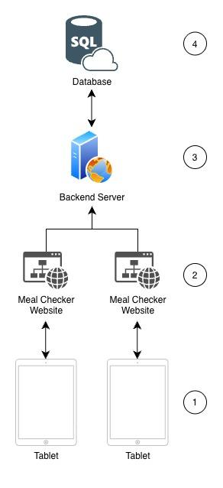
Costs per Components

1. Physical Setup
The physical setup requires three distinct stations: two for standard barcode scanning (to keep lines moving fast) and one for manual entry and meal swaps.

This requires three tablets (and mounts/cases) and two barcode scanners (and mounts). Cost for this is open-ended depending on what the club chooses to buy. I can find recommendations if requested. For now, we can estimate this at a $400 one-time cost.

2. Frontend Website
The website will be hand-coded using a JavaScript framework known as Next.js to avoid costs with other website builders.

One main cost with a website is often the website domain, but we will be adding this website as a sub-domain of the Cap & Gown domain (meals.capandgownclub.org), avoiding any additional costs.

Another major cost with a website is hosting it (where the website code will be run), but we will host it in the same place as the backend server (where the business logic code will be run). See the next section for details.

3. Backend Server
The code for the backend server (and the code for the frontend website) needs to be run on a server. Vercel is a service that allows us to host our code on their servers. The free Hobby tier gives us 1 million function executions and 100GB of bandwidth per month. Our maximum of 30,000 monthly scans will barely scratch the surface. Therefore, we can get away with $0/month.

4. Database
As per our System Design document, we need a PostgreSQL Database and the best cost-effective service to provide this type of database at our small scale is Supabase. The free tier gives you 500MB of database space and 2GB of bandwidth. Storing thousands of 50-byte check-in records will take years to reach 500MB. Therefore for strictly storage, we can get away with $0/month.

However, Supabase automatically pauses free databases after 7 days of inactivity to save server resources. During the semester, this is fine. However, during breaks, the database will spin down.

When the business manager returns after a week-long break, the first scan will fail unless someone logs into the Supabase dashboard and manually clicks "Unpause" (which takes about 2 minutes to boot up).

To prevent this and keep the database active 24/7/365, the club would need to upgrade to the Pro plan at $25/month. This is one decision that is up to you if this pain is worth upgrading for.

Total Technical Cost Breakdown
Component | Up Front Cost | Recurring Annual Cost | Upgraded Annual Cost
Physical Setup | ~$400 | $0 | $0
Frontend Website | $0 | $0 | $0
Backend Server | $0 | $0 | $0
Database | $0 | $0 | $300
Total | ~$400 | $0 | $300

Developer Cost
Estimating a quote for the one single, flat fee that covers both the upfront development of the software and my ongoing technical support through the end of my senior year.

What this covers
- End-to-End Development: Designing, coding, and deploying the tablet web app, the backend API logic, and the PostgreSQL database.
- The Admin Dashboard: Building a secure web portal for real-time analytics and roster management.
- Hardware Setup & Testing: Configuring the tablets and scanners on-site and testing the offline-syncing capabilities on the club's Wi-Fi.
- Regular Tech Support for the 2026-2027 Academic Year: I will remain on-call through graduation to fix any bugs, adjust features, and ensure the system runs flawlessly during its inaugural year.

Coming Up With Estimate
If Cap and Gown were to hire a local New Jersey digital agency or a professional freelance engineer to design and build this custom point-of-sale system, the standard market rate would range from $7,500 to $12,500+, not including maintenance fees.

I wanted to come up with a number that was fair because at the end of the day, I'm just doing this for my eating club and its success. I also wanted to come up with a number that makes it realistic that I dedicate the time to make this system, make it right, and be there to make sure it goes smoothly the entire first year. The number I can do this for is $2,000 on completion.

